# Axis Auto PDF Sweeping

As of November 2019, we are changing the way we send data to Axis (our print vendor for PCMS, MedRec and Provider letters). This currently is a very manual process based on an “approved” status on a communication.

### Coding Solution

SSIS Packages and Solution: \\sqlrdp\artifacts\prod\com.pharmmd.outboundDataFeed.ClientGenericNightlyExtracts\NightlyClientExtracts\NightlyClientExtracts

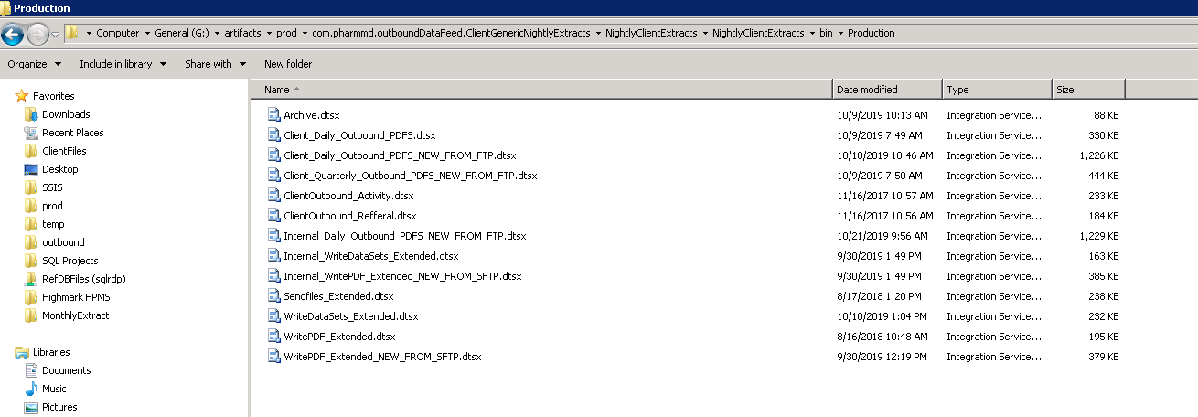The location of the packages is listed above. Note: Packages must be manually copied into the Production folder. This is my standard process and ensures things are only deployed when they are ready to go.

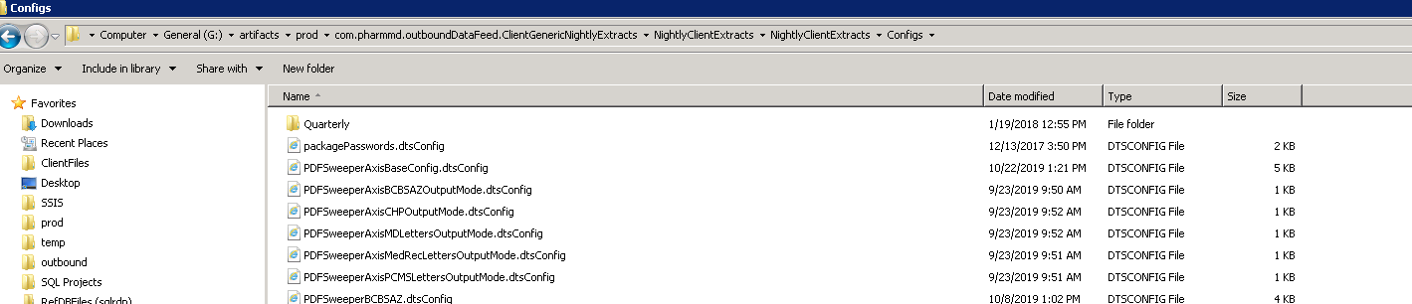

The location for the configuration files is listed above. These are important and are attached to each scheduled SQL Agent Job step (see below). There is currently a max on how many PDFs we can send per type per day (just to make sure we don’t blow up P3). This is controlled in the “AxisBaseConfig” file. The base configuration is used for all packages and to keep things centralized.

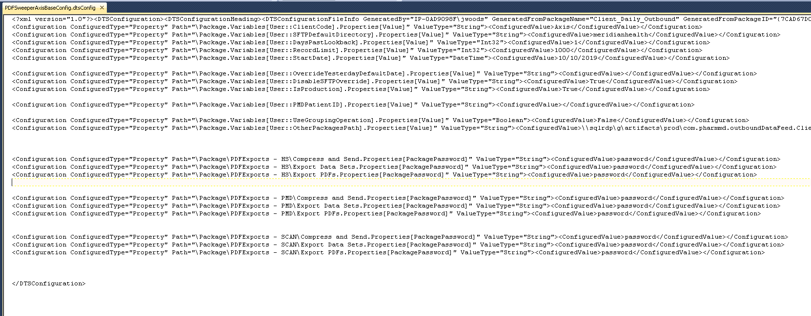

Configuration file example (the base)

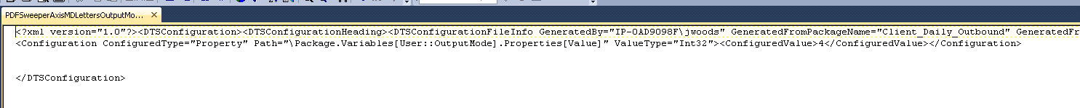

Configuration file example (specific output modes)

### SQL Agent Job



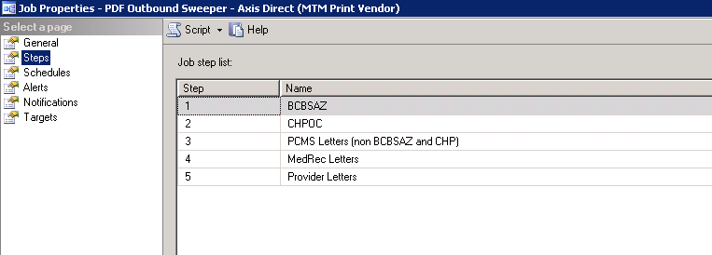

There are 5 output types (the specific output type is listed in the package but also in a table on SQLETL).

* BCBSAZ PCMS Letters
* CHPOC PCMS Letters
* PCMS Letters
* MedRec Letters
* Provider Letters

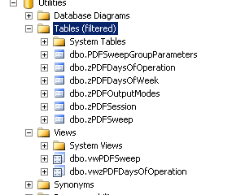

Tables and views in the Utilities database. This dictates sessions that are run (when the sweeps kick off), the files that are swept (based on session), the output modes (as listed above), and the days that the sweep is run per mode (use the handy dandy Views for this).

The zPDFSweep table is the one that is used to loop through near the end of the process to update the swept_internal_at process in Postgres (it will touch HS, PMD and SCAN).

Each of the 5 output types has a separate SQL script expression but the basis is below:

select count(*) from(select member_id, description, fileNameOld as filename, outputfilename, createdat as createdAt, publishdate, contractid ,"group", pmd_patient_id, organization_id, patient_id, communication_id, delivery_method, account from(select *,createdat+TrueCreatedAt2::interval as TrueWithTimeZone, status from (select Distinct pt.member_id , c.label as description , cast(pdf.communication_id || '.pdf' as character varying (1000)) as fileNameOld, pdf.created_at as createdat ,cast (current_date as timestamp ) as publishDate ,c.label || '.pdf' as OutputFileNameOld, cast(fx_pdf_name(c.id) || '.pdf' as character varying) as OutputFileName, pt.account as ContractID,pt."group", timezone('US/Central',pdf.created_at) as TrueCreatedAt, pdf.created_at-timezone('US/Central',pdf.created_at) as TrueCreatedAt2, c.id, pmd_patient_id , pt.organization_id, pt.id as patient_id, c.id as communication_id, c.delivery_method, c.status, pt.account from communication_pdfs pdf inner join communications c on pdf.communication_id = c.id inner join patients pt on c.patient_id = pt.id inner join organizations o on pt.organization_id=o.id where pdf.id is not null and c.deleted_at is null and o.pmd_client_id not in (79.83) and c.status='approved' and c.updated_at&gt;='10/16/2019' and c.swept_internal_at is null )T)T1 where id is not null ;) T

In human readable language, this is getting everything with a swept_internal_at value of null (we did NOT backfill communications before we started this process) and with a status of “approved” on the communication and an updated_at date (which should be the approval date) of the start date of this process (currently planned for 10/30/2019)

Output File Location:

The PDFs will be swept here: \\sqlrdp\External\Fulfillment\Axis Automatic SFTP Uploads. They are date and time stamped and have the particular output mode in there.

### Future/To Do

Infrastructure needs to create a solution to get the files automatically from the ClientFiles/Axis/Outbound/Reports structure directly to the Axis SFTP.

### Update History

|  |  |  |
| --- | --- | --- |
| Version | Notes | Date |
| 1.0 | Creation | 10/23/2019 |